

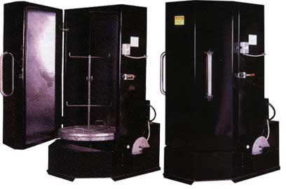

HARRIS TOOL COMPANY MODEL NO. WA-TR 30 X 54 FRONT LOAD MEDIUM DUTY WASHER WITH FOLLOWING MACHINE SPECIFICATIONS:

- 15 MIN. SPRING WOUND TIMER OPERATED STAINLESS DISC TYPE OIL SKIMMER
- 4.5KW ELECTRIC HEATER
- TANK DEBRIS SCREEN(170 SQ. IN.)
- 2 HP SELF PRIMING CENTRIFUGAL PUMP W/DOWN SUCTION SPOUT(92 GPM @ 16 PSIG)
- 60 MIN.SPRING WOUND WASH TIMER
- THERMOSTAT SWITCH W/ 175 DEGREES F SETTING
- 22 SPRAY JETS
- 50 GALLON CLEANING SOLUTION TANK
- 500 LB. LOAD CAPACITY
- 1/15 HP GEARMOTOR/WIRE WHEEL DRIVEN 30” DIA.TURNTABLE BASKET W/ PARTS RING & STANDARD BEARING DESIGN
- 208-240/60/1 ELECTRICAL REQUIREMENTS
- 14 GAUGE TANK & CABINET STEEL PLATE MATERIAL
- HINGED DOOR W/ HANDLE, LATCH, SAFETY SWITCH, & MECHANICAL SEAL(NO RUBBER GASKETS TO WEAR OUT)
- 2 ½” DIA. CASTERS
- 54” INSIDE & 78” OVERALL HEIGHT
- 44”W X 43”D FLOOR SPACE REQUIRED W/ DOOR CLOSED
- REMOVEABLE PARTS TREE & BASKET
- PRECAUTION BLUE PAINT
- 750 LBS. SHIPPING WT.

